**How to edit the condition record?**

1. Using FV12 to edit the condition record.

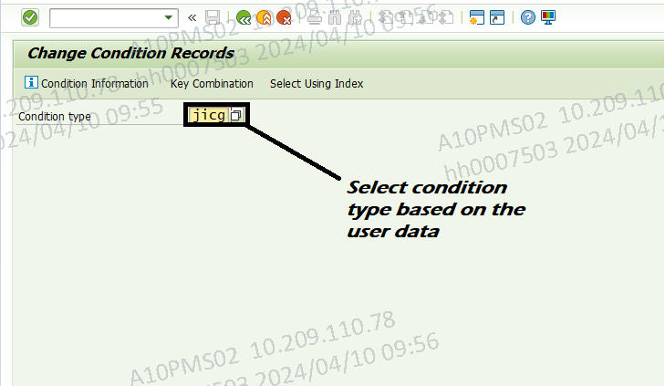

2. Press enter key. Select the key combination based on the tax or destination code.

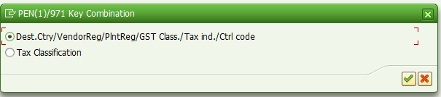

3. Press enter key.

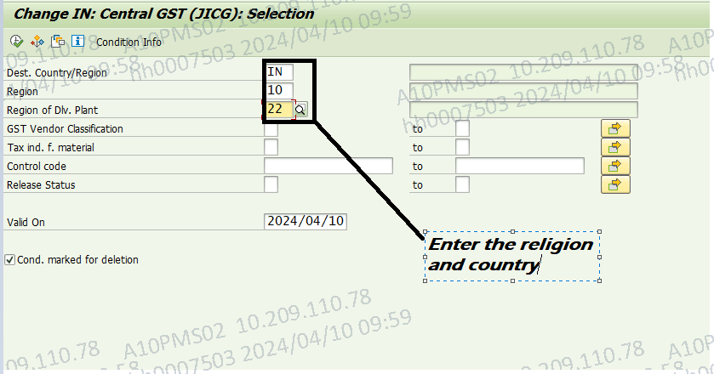

4. Click F8 and edit the data.

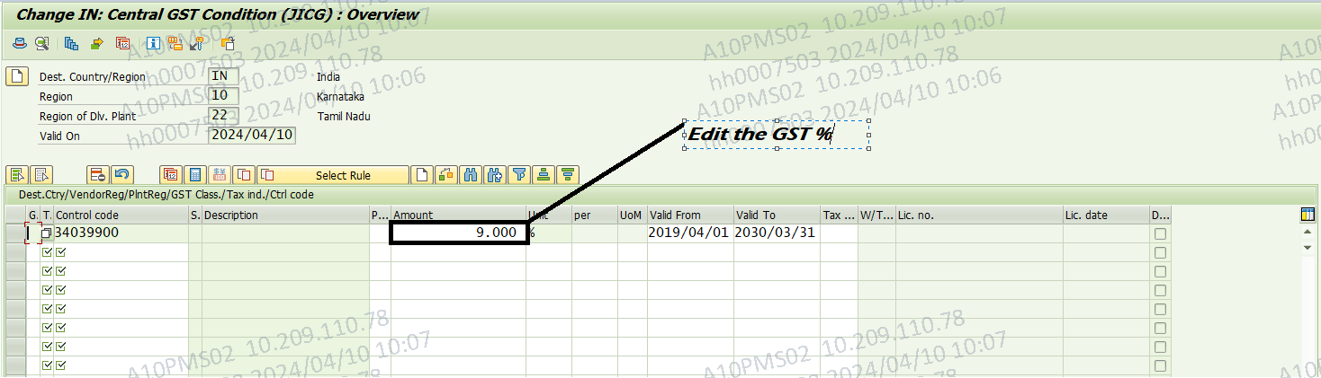

5. Click Save.

